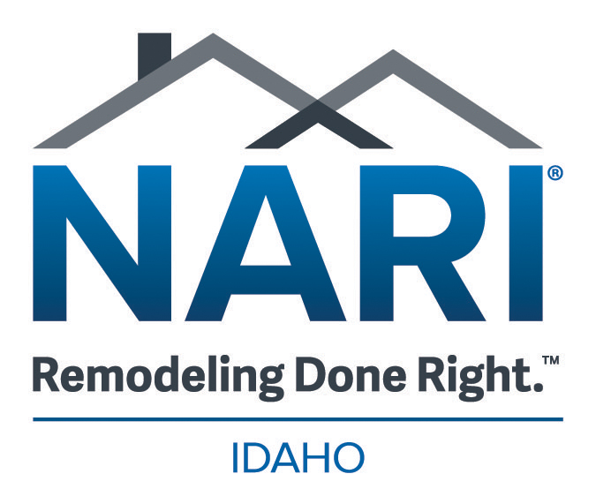WAIVER OF LIABILITY AND HOLD HARMLESS AGREEMENT

FOR

CONTRACTORS WHO CARE AND NARI IDAHO CHAPTER

- In consideration for receiving services from Contractors Who Care and NARI Idaho Chapter, I hereby RELEASE, WAIVE, DISCHARGE AND COVENANT NOT TO SUE Contractors Who Care, NARI Idaho Chapter, their officers, agents, volunteers or employees(herein referred to as RELEASEES) from any and all liability, claims, demands, actions and causes of actions whatsoever arising out of or related to any loss, damage, or injury that may be sustained by me, or my representatives, or any of the property belonging to me or the organization, WHETHER CAUSED BY THE NEGLIGENCE OF THE RELEASEES, or otherwise, while participating in this program, or while in, on or upon the premises where services are being rendered.
- I am fully aware of the risks involved connected with these services. I hereby elect to voluntarily participate in the receipt of these services with full knowledge that said services may be hazardous to me and my property. I voluntarily assume full responsibility for any risks of loss, property damage or personal injury that may be sustained by me, or any loss or damage of property owned by me or the organization, as a result of being engaged in such activity, whether caused by the negligence of releasees or otherwise.
- I further hereby agree to indemnify and hold harmless the releasees from any loss, liability, damage or costs, including court costs and attorney fees, that may be incurred due to my participation in said services, whether caused by negligence of releasees or otherwise.
- I understand that Contractors Who Care and NARI Idaho Chapter is providing services at no charge, including but not limited to labor and materials, and does not maintain any insurance policy covering any circumstance arising from my participation in these services or any activity associated with or facilitating that participation. As such, I am aware that I should review my personal insurance portfolio or that of the organization and maintain during the course of services rendered a policy of insurance for fire and loss to property.
- It is my express intent that this Waiver of Liability and Hold Harmless Agreement shall bind the members of my family and spouse, if I am alive, and my heirs, assigns and personal representative or organization, if I am deceased, and shall be deemed as a release, waiver, discharge and covenant not to sue the above named releasees. I hereby further agree that this waiver of liability and hold harmless agreement shall be construed in accordance with the laws of the State of Idaho.
- In signing this release, I acknowledge that I have read the foregoing waiver of liability and hold harmless agreement, understand it and sign it voluntarily as my own free act and deed; no oral representations, statements, or inducements, apart from the foregoing written agreement, have been made; I am at least eighteen (18) years of age and fully competent; and I execute this release for full, adequate and complete consideration fully intending to be bound by same.

Signed on this _______day of ________, ____ (year).

Receiver of Services or Representative
_____________________________ _____________________________
Printed Name Signature

